1. Start the Terminal program from the top menu bar (Applications -> Accessories -> Terminal).

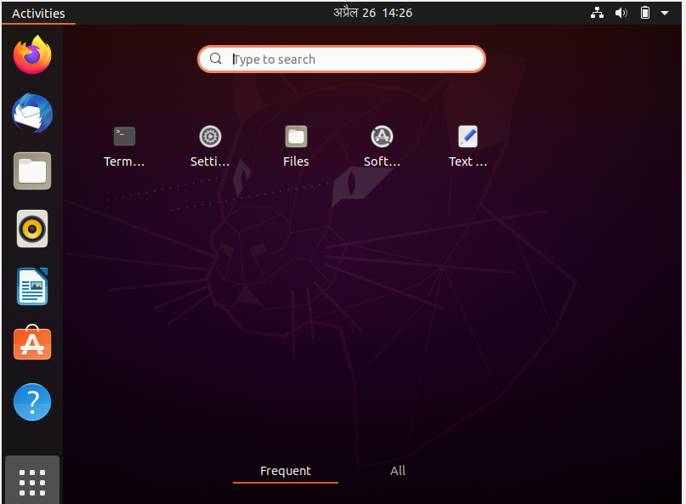

1. Use commands cd, cd .. , cd / to navigate through the directories. Create the directory HCK in the desktop.

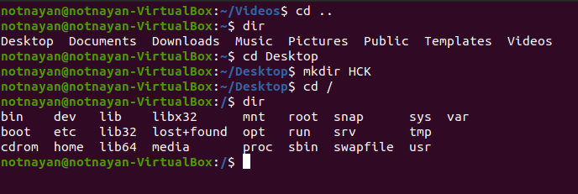

1. Write the command to print current working directory. List the files and directories in the current working directories. *Insert the image of your terminal here.*

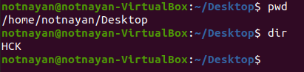

1. Create New.txt file containing text *“Herald College Kathmandu”*, in the HCK directory.

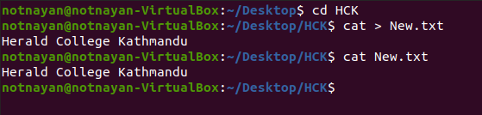

1. Delete New.txt file from HCK directory.

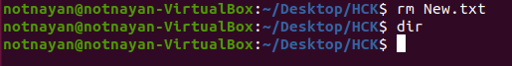

1. Remove directory HCK form the Desktop.

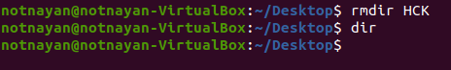

1. Create directory Kathmandu in the desktop containing file Swyambhu.txt,

Rename Swayambhu.txt as Barahi.txt

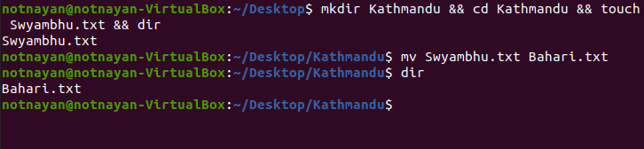

1. Create Directory Pokhara in the Desktop and move Bahari.txt of directory

Kathmandu in directory Pokhara.

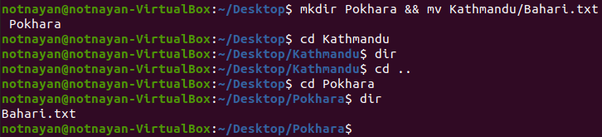

1. What is the command to list all the invisible files and to display the directories in detail?

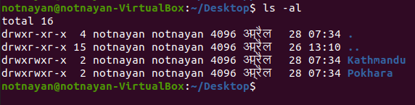

1. What is the command to make a directory named IPHONE and IPAD and remove the directory named IPAD?

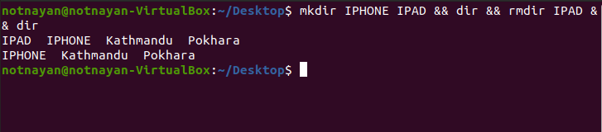

1. Create file hck.txt containing text “Herald College Kathmandu” and another file hck1.txt containing text “Sanugaucharan, Naxal” concatenate these two files and give name HCK.txt.

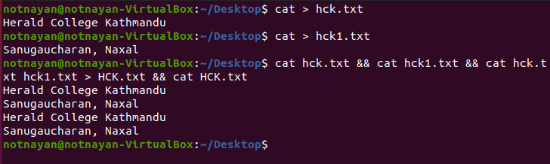

1. Create filename1.txt and filename2.txt in the Desktop and create compressed file new.zip which contains filename1.txt and filename2.txt.

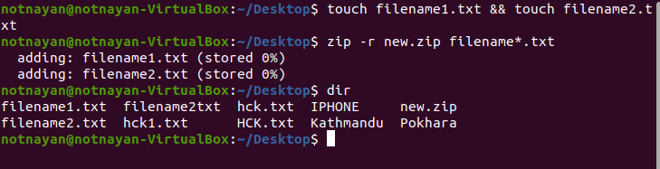

1. Check the permissions for User, group and world for new.zip and set read permission for user, read and write permission for group and read write and execute permission for world.

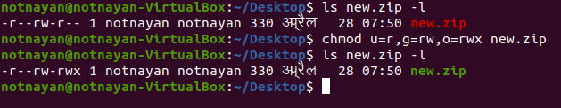

1. Write the command to check your last 10 commands.

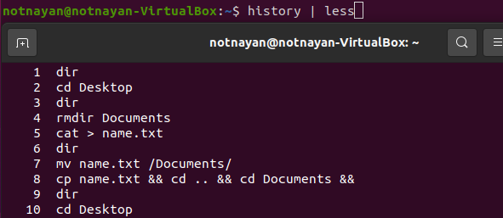

1. Write the command to check current user.

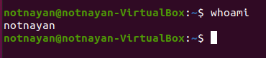

1. Write the command to add user having user name newuser and switch to newuser.

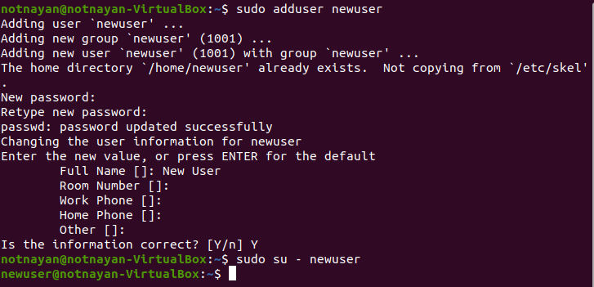

1. Create the following directories in and paste your result here.

